Nama : Aldo Spama Putra Suir

No BP : 2001082033

**Tahapan membuat RESTful API**

**Bussines flow =>UI/UX screen => API Documentation => Develop RESTful API**

* **Bussiness Flow**

|  |
| --- |
| **Form Penduduk** |
|  |
| **No KTP** |  |
| **Nama** |  |
| **Tempat Tanggal Lahir** |  |
| **Jenis Kelamin** |  |
| **Golongan Darah** |  |
| **Agama** |  |
| **Pekerjaan** |  |
| **Status** |  |
| **Alamat** |  |

* **UI/UX Screen**

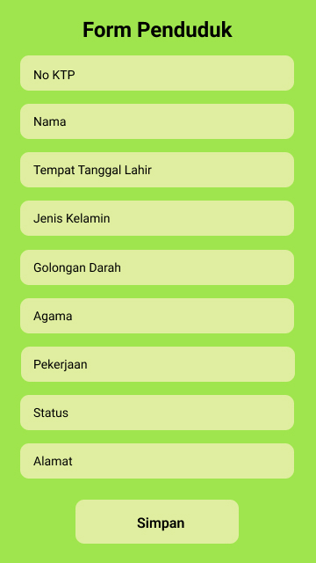

* **API Documentation**

|  |
| --- |
| **Form Penduduk** |
| POST/data_penduduk |
| GET/data_penduduk |
| GET/data_penduduk/:no_ktp |
| PUT/data_penduduk/:no_ktp |
| DELETE/data_penduduk/:no_ktp |

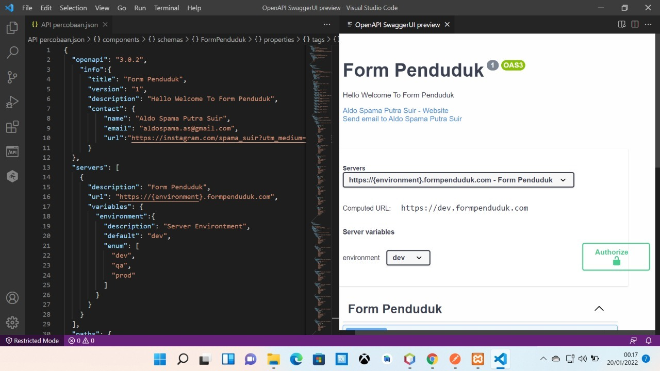

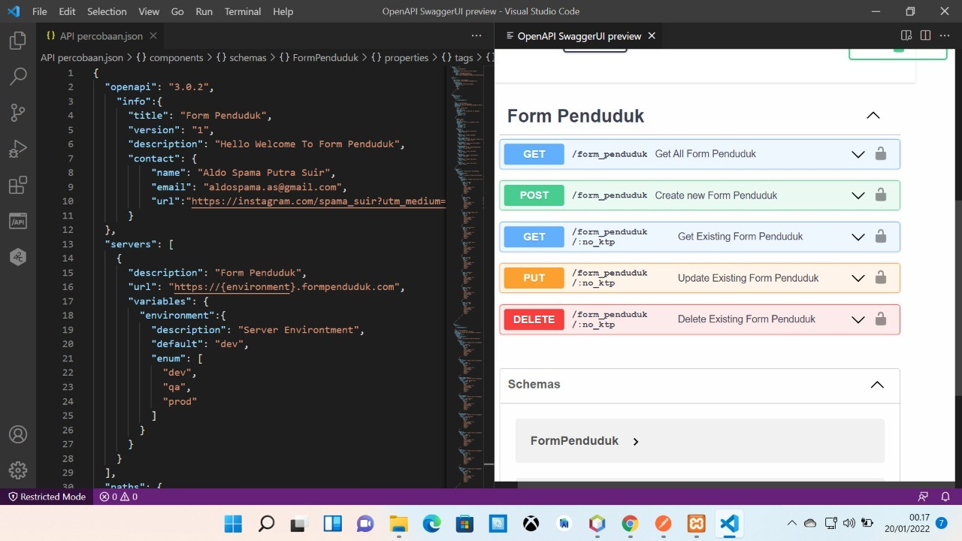

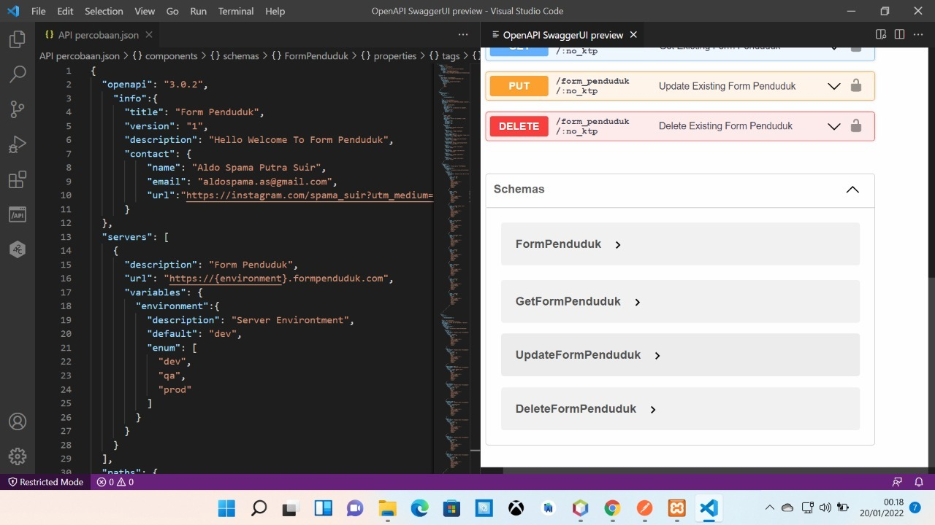

* **Develop RestFul API**

